**JOB 3: ENHANCED OPPORTUNITY SHORE FISHING PROGRAM**

**JOB 3:** **ENHANCED OPPORTUNITY SHORE FISHING PROGRAM**

**TABLE OF CONTENTS**

Page

Goal…………………………………………………………………………….….…… 3

Objectives……………………………………………………………………….……… 3

Introduction.…………………………………………………...…………….…………. 3

Methods.…………………………………………...…………………………....……… 4

Results and Discussion…………………………………...………………………..…… 5

Modifications…………………………………….………………..…………………… 5

**LIST OF TABLES**

Table 3.1 Assignments by month and zone …………………….……….….….......... 6

Table 3.2 Sites visited by month and zone ………………………………………….. 6

Table 3.3 Number of intercepts and total number of anglers interviewed by month... 6

Table 3.4 Catch disposition from Enhanced Shore Fishing Sites ……….…….......... 7

Table 3.5 Length measurements of finfish from Enhanced Shore Fishing Sites…..... 8

**LIST OF FIGURES**

Figure 3.1 Length frequencies of popular marine fish measured at Enhanced

Shore Fishing Sites…………………………………………………….... 9

**APPENDICES**

Appendix 3.1 Map of Enhanced Shore Fishing Sites.……..……..………….……..10

Appendix 3.2 Enhanced Shore Fishing Site Catch Card…………………………...10

Appendix 3.3 List of Enhanced Shore Fishing Sites……..………………………...10

**JOB 3: ENHANCED OPPORTUNITY SHORE FISHING PROGRAM**

**GOAL**

**To maintain and improve the fishing experience, opportunity and quality of access to public trust marine fisheries resources in Connecticut especially in urban areas, while maintaining marine fish conservation objectives.**

**OBJECTIVES**

1. *Preserve the quality of shore fishing opportunity for species whose management is heavily minimum size dependent, while also meeting fishery management plan conservation objectives.*
2. *Collect data from the designated enhanced shore fishing sites necessary to gauge the biological and social impact of enhanced opportunity and whether fishery management plan harvest targets are still being met.*
3. *Create an “adopt-a-shore-site” relationship with tackle shops that are located near specific sites to help maintain and manage locations.*
4. *Establish contacts with local officials of town-owned sites especially within urban areas to increase awareness and appreciation of quality shore based recreational fishing opportunity in their community.*
5. *Increase public awareness of the sites to encourage activity by increasing communication with tackle shops and anglers.*

**INTRODUCTION**

DEEP Marine Fisheries has identified the need to enhance fishing opportunity for shore based anglers. To meet this need, the agency designated shore based fishing sites (see Appendix 8.1) which allowed for less restrictive fishing regulations. Anglers fishing from designated enhanced opportunity shore fishing sites in 2016 were allowed to harvest scup at 9 inches minimum length (vs. 10.5 inches in other private fishing modes and 11 inches for party/charter modes) and summer flounder at 16 inches (vs 18 inches for other modes). The smaller minimum sizes were adopted out of concern that shore anglers were taking a disproportional share of the conservation burden associated with the increased minimum sizes adopted in response to the harvest limits established under the joint ASMFC/MAFMC fishery management plans for these species. In order to ensure that these less restrictive regulations meet the required conservation of the fishery management plan, The Atlantic States Marine Fisheries Commission (ASMFC) Summer Flounder, Scup and Black Sea Bass Management Board requested that DEEP monitor of the enhanced shore fishing sites to provide additional catch information.

A voluntary daily angler catch card program was developed to collect fishing trip and catch information, including length measurements of harvested and released (discarded) fish from recreational anglers at the enhanced shore fishing sites. Collecting length measurement data, especially on discarded fish, is extremely difficult to obtain through traditional access point angler intercept surveys (e.g. MRIP). In past years, such length data has been successfully collected utilizing volunteer anglers to report their fishing trip information through a logbook survey (VAS, Job 2) and this program was used as a template for the more extensive catch card program (see Appendix 3.2).

**METHODS**

Five assignment zones for sampling were established comprising a total of 39 of the 46 Enhanced Shore Fishing Sites from Stonington to Norwalk (Figure 3.1). For each assignment, the zone, time of day (am or pm), starting site and direction of travel was randomly selected using the SAS ‘ranuni’ function. Upon arriving at a site, the creel agent would record:

* Date and time of creel agent arrival
* Weekend or weekday
* Site name
* Initial count of angler(s)
* Arrival and departure time of additional anglers
* Date and time of creel agent departure

Each angler was asked to participate in an angler survey to provide fishing effort and catch information. If they agreed, the creel agent would perform a partial trip interview. The following questions were asked:

* What time did you start fishing?
* Have you been interviewed by this program already this year?
* What species are you fishing for?
* How many times do you go saltwater fishing per year?
* Of those, what percent are from shore?
* Are there any comments you would like to make about shore fishing in CT (pro’s or con’s).
* Have you caught any fish yet on this trip? If yes, how many fish of each species did you catch?

All fish caught while the creel agent is on site are measured and recorded. To capture the remaining catch and effort information, each participating angler was provided with a waterproof daily catch card, pencil, measuring tape, and verbal instructions by DEEP staff. Anglers were asked to fill out the following (data fields):

* Conservation identification number (fishing license number)
* Primary target species
* Secondary target species
* Total hours spent fishing
* Date (mm/dd/yy)/start time (check box AM/PM)
* Total number of fish kept and released by species
* Length measurements for the first seven fish caught.

Anglers were encouraged to mail in the post-marked catch card or deposit it into designated drop-off-boxes installed at fishing sites upon trip completion. Also, questions concerning the survey could be answered by contacting the DEEP Marine Headquarters office.

**RESULTS AND DISCUSSION**

Catch cards that were distributed to shore anglers were categorized by identification number, date, and enhanced shore fishing site code. From May through December 2016 there were a total of 76 assignments (Table 3.1) attributed to500 sites sampled (Table 3.2) in four zones. The largest number of intercepts and interviews occurred in June (Table 3.3).

A total of 874 catch cards were distributed to anglers at enhanced shore fishing sites and 308 (35%) were returned. The reported catch included 18 species/taxonomic groups totaling 1,014 fish (Table 3.4) similar to the total for partial trip interviews as described in methods. The majority of the fish (71%) were released due to regulatory discard or undesirable catch. The total harvest reported was 297 fish comprised of 11 species.

**Length Information**

Each individual angler reported the common name(s) of the first seven fish captured, regardless of species and size. A total of 515 fish measurements by anglers and 409 fish measurements by agents were received, comprising 20 species (Table 3.5). Scup, sea robin, bluefish and striped bass were the most frequently harvested species measured by anglers (Figure 3.1), and comprised 69% of the total measured catch.

**Enhanced shore fishing**

Although sample sizes are small, data gathered from this program indicate that having a minimum length of 9 inches at the Enhanced Sites improved the success rate for shore based scup anglers by 45% compared to anglers complying with the previously higher legal minimum length of 10 inches required at other shore locations. This increase is a near doubling of the 21% recorded in 2014, which was the first year of the program. Shore-based summer flounder anglers improved their success rate by 66% compared to anglers complying with legal minimum length requirements, similar to the 29% increase recorded in 2014. The success rates for each species were calculated using the length frequencies of kept fish from the returned catch cards. Specifically, the proportion of scup harvested between 9 and 10 inches and the proportion of summer flounder harvested between 16 and 18 inches.

**MODIFICATIONS**

No modifications are expected.

**Table 3.1: Assignments by month and zone.**

|  |  |  |  |  |  |
| --- | --- | --- | --- | --- | --- |
| **Month** | **Zone1** | **Zone2** | **Zone3** | **Zone4** | **Total** |
| **May** | 4 | 4 | 4 | 1 | **13** |
| **June** | 4 | 4 | 5 | 2 | **15** |
| **July** | 3 | 2 | 1 | 3 | **9** |
| **August** | 2 | 3 | 2 | 2 | **9** |
| **September** | 2 | 3 | 2 | 1 | **8** |
| **October** | 5 | 4 | 3 | 3 | **15** |
| **November** | 2 | 2 | 1 | 1 | **6** |
| **December** | 0 | 0 | 0 | 1 | **1** |
| **Total** | **22** | **22** | **18** | **14** | **76** |

**Table 3.2: Sites visited by month and zone.**

|  |  |  |  |  |  |
| --- | --- | --- | --- | --- | --- |
| **MONTH** | **Zone1** | **zone2** | **zone3** | **zone4** | **total** |
| **MAY** | 24 | 32 | 24 | 6 | **86** |
| **JUNE** | 24 | 32 | 30 | 12 | **98** |
| **JULY** | 18 | 16 | 6 | 18 | **58** |
| **AUG** | 12 | 24 | 12 | 12 | **60** |
| **SEPT** | 12 | 24 | 12 | 6 | **54** |
| **OCT** | 30 | 32 | 18 | 18 | **98** |
| **NOV** | 12 | 16 | 6 | 6 | **40** |
| **DEC** | 0 | 0 | 0 | 6 | **6** |
| **TOTAL** | **132** | **176** | **108** | **84** | **500** |

**Table 3.3: Fishing parties intercepted and total anglers interviewed by month.**

|  |  |  |  |
| --- | --- | --- | --- |
| Month | Intercepts (parties) | | Anglers Interviewed |
| MAY | 78 | | 118 |
| JUN | 151 | 219 | |
| JUL | 90 | 129 | |
| AUG | 120 | 168 | |
| SEP | 65 | 82 | |
| OCT | 88 | 122 | |
| NOV | 27 | 38 | |
| DEC | 1 | 1 | |
| Total | **620** | **877** | |

**Table 3.4: Catch disposition from Enhanced Shore Fishing Sites.**

|  |  |  |  |  |  |  |  |
| --- | --- | --- | --- | --- | --- | --- | --- |
|  | **RETURNED CREEL CARDS** | | | | **PARTIAL INTERVIEW** | | |
| **SPECIES** | | **RELEASE** | **KEPT** | **TOTAL** | **RELEASE** | **KEPT** | **TOTAL** |
| **ATLANTIC MENHADEN** | 0 | | 26 | 26 | 7 | 55 | 62 |
| **BLACK SEA BASS** | 32 | | 3 | 35 | 33 | 0 | 33 |
| **BLUEFISH** | 67 | | 61 | 128 | 38 | 60 | 98 |
| **CATFISHES** | 1 | | 8 | 9 | 1 | 8 | 9 |
| **CLEARNOSE SKATE** |  | |  |  | 1 | 0 | 1 |
| **CUNNER** |  | |  |  | 1 | 0 | 1 |
| **DOGFISH UNC** | 2 | | 0 | 2 | 2 | 0 | 2 |
| **HICKORY SHAD** | 75 | | 16 | 91 | 17 | 12 | 29 |
| **NORTHERN KINGFISH** | 1 | | 0 | 1 | 0 | 1 | 1 |
| **SCUP** | 205 | | 157 | 362 | 112 | 236 | 348 |
| **SEA ROBINS UNC** | 148 | | 6 | 154 | 151 | 13 | 164 |
| **SKATES UNC** | 2 | | 0 | 2 | 1 | 0 | 1 |
| **SPOTTED HAKE** | 1 | | 0 | 1 |  |  |  |
| **STRIPED BASS** | 102 | | 4 | 106 | 26 | 3 | 29 |
| **STRIPED SEA ROBIN** | 8 | | 1 | 9 | 14 | 3 | 17 |
| **SUMMER FLOUNDER** | 44 | | 9 | 53 | 57 | 7 | 64 |
| **TAUTOG** | 23 | | 6 | 29 | 37 | 3 | 40 |
| **WEAKFISH** | 4 | | 0 | 4 | 1 | 0 | 1 |
| **WINTER FLOUNDER** | 1 | | 0 | 1 |  |  |  |
| **NORTHERN PUFFER** | 1 | | 0 | 1 | 3 | 0 | 3 |
| **COMBINED TOTAL** | **717** | | **297** | **1014** | **502** | **401** | **903** |
| **PERCENT OF TOTAL** | **71%** | | **29%** |  | **55%** | **45%** |  |

**Table 3.5: Length measurements of finfish captured at Enhanced Shore Fishing Sites.**

|  |  |  |  |
| --- | --- | --- | --- |
| **SPECIES** | **MEASURED BY ANGLER** | **MEASURED BY AGENT** | **TOTAL LENGTHS** |
| **ATLANTIC MENHADEN** | 14 | 31 | 45 |
| **BLACK SEA BASS** | 18 | 6 | 24 |
| **BLUEFISH** | 74 | 59 | 133 |
| **CATFISHES** | 9 | 8 | 17 |
| **CUNNER** |  | 1 | 1 |
| **CLEARNOSE SKATE** |  | 1 | 1 |
| **DOGFISH** | 2 |  | 2 |
| **HICKORY SHAD** | 28 | 8 | 36 |
| **NORTHERN KINGFISH** | 1 | 1 | 2 |
| **SCUP** | 129 | 229 | 358 |
| **SEA ROBIN UNC** | 94 | 18 | 112 |
| **SKATE UNC** | 2 |  | 2 |
| **SPOTTED HAKE** | 1 |  | 1 |
| **STRIPED BASS** | 58 | 8 | 66 |
| **STRIPED SEA ROBIN** | 9 | 17 | 26 |
| **SUMMER FLOUNDER** | 45 | 16 | 61 |
| **TAUTOG** | 26 | 5 | 31 |
| **WEAKFISH** | 4 | 1 | 5 |
| **WINTER FLOUNDER** | 1 |  | 1 |
| **NORTHERN PUFFER** | 0 |  | 0 |
| **COMBINED TOTAL** | **515** | **409** | **924** |

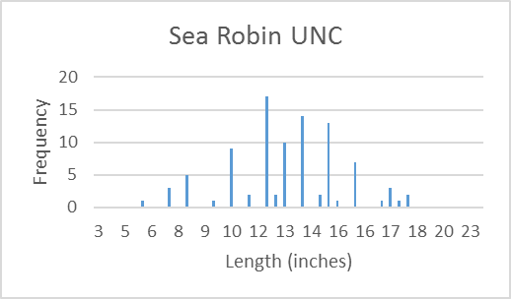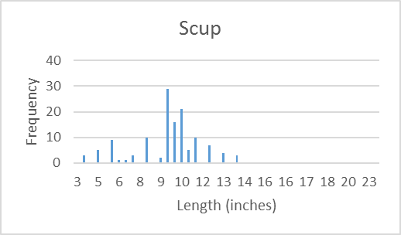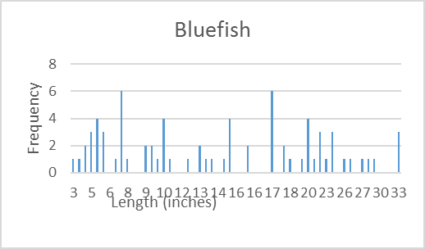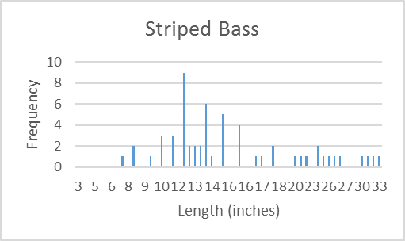

**Figure 3.1: Length frequencies of popular marine fish measured at Enhanced Shore Fishing Sites.** Total length is rounded down to the nearest half-inch.

**Appendix 3.1:** Map of Enhanced Shore Fishing Sites

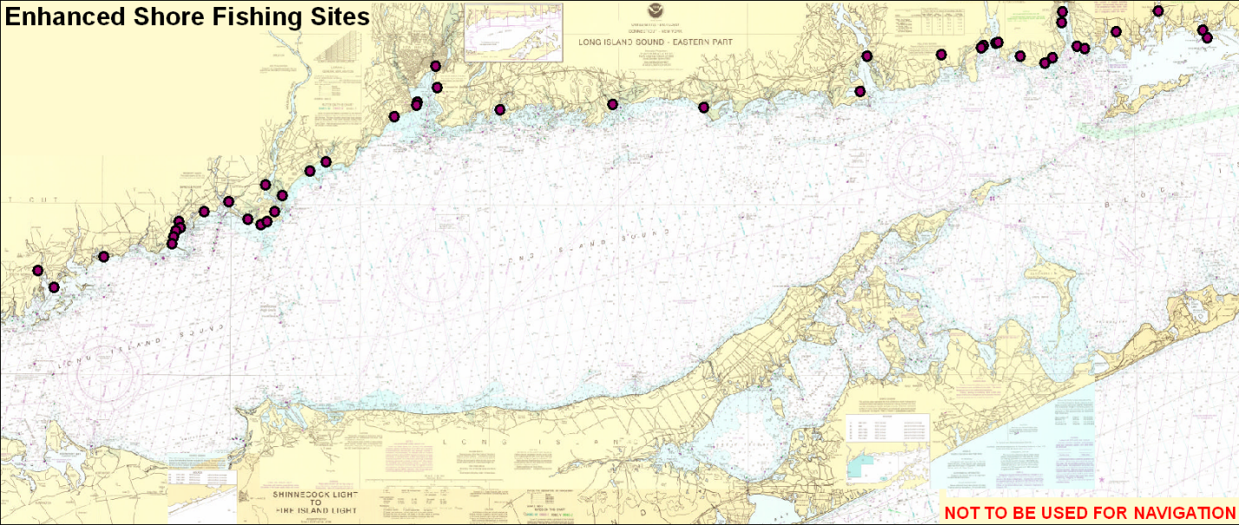

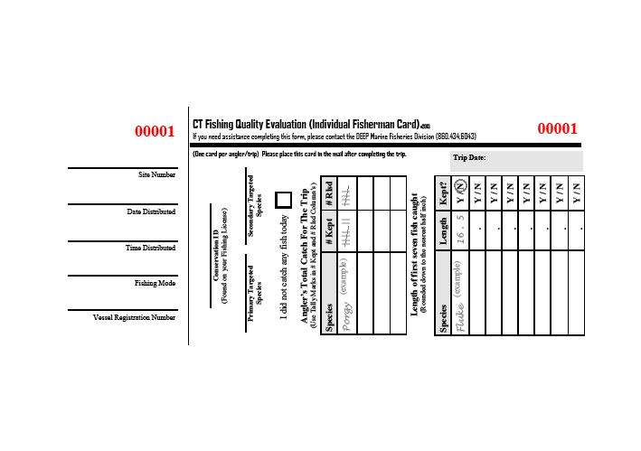

**Appendix 3.2: Enhanced Shore Fishing Site Catch Card**

**Appendix 3.3: List of Enhanced Shore Fishing Sites**

